**Employee Performance**

# **II. Abstract**

Employee performance can be impacted by various factors. One of the factors that has been playing an important role in employee work performance since COVID-19 is the opportunity to work remotely. Our study will try to determine whether performance may or may not depend on personal factors such as gender, marital status or mode of work (remote, hybrid or in-person). Our study involves surveying family, friends and colleagues to assess the results against our hypothesis that personal factors DO NOT affect employee performance. The survey included participants from two main countries, India and the United States, as well as, minimal participation from Canada and Czechia and age varied from 13-70+.

**III. Introduction**

What causes work performance to vary? Can work performance be tied to any one cause? Or is work performance caused by factors within each individual employee's personal life? The purpose of this paper is to find out if a given group of surveyed individuals can help determine if one of the handfuls of determinants answered by completing our survey in order to help us understand more about individual work performance.

It is always surprising to learn that certain assumptions can be made about such common themes such as work performance. One could almost assume that work performance is related solely to experience, but everyone knows what making assumptions does… just because you prepare very well for an exam or job interview, it could go completely different from what you were expecting. This unexpected result could be attributed to a myriad of causes, such as, the professors exam types, an error in the course materials, a time mix up in the scheduled interview time, and so forth.

Our survey starts by asking basic personal data questions regarding age, gender, marital status, city and country of inhabitants, years of work experience and mode of working. The next set of questions are geared towards preference and perspective and focus on a set of tests against the hypothesis in order to extrapolate the necessary data to make a conclusion. We also move into preferences and perspectives on self reported work performance. The work performance survey measurement is not quantified objectively from the outside but more from an individual personal assessment. Each individual must make a decision whether or not their performance is being affected by their personal factors, preference, both or neither.

# 

# 

# **IV. Hypothesis**

We thought for the purpose of testing our hypothesis we should include the fact that individual work landscapes have changed significantly over the last few years and we included the mode of work as a function as well as a preference for the purpose of gathering more in depth data.

Our Null Hypothesis states: **Employee's personal factors do not affect employee's on-site performance and/or remote performance.**

We also state our Alternative Hypothesis as: **Employee's personal factors do affect employee's on-site performance and remote performance.**

**V. Method(s) / Tools**

Our goal was to assess performance analysis when working in-person, remotely, or in a hybrid environment. We will need the following tools and methods to do this. The initial step was to identify participants who might respond to our questionnaire without bias. Essentially, our objective was to determine a target audience for this survey. We subsequently developed a series of questionnaires that could be implemented in our survey to collect all the responses. To conduct statistical analysis of the data we used SPSS to perform several sorts of analytics on the data we gathered. We used Tableau to visualize the results and performed factor analysis and regression analysis. Regression analysis will help us to find a correlation between two variables and be able to find strong (positive) or weak (negative) relationships for defined variables. For example:

Fig 1: Scatter plot for Experience vs Age

Factor analysis will help us to find different survey questions and analyze the answers. This will also help us to group the questions based on the trend of response.  This analysis examines the pattern of responses of respondents to questionnaire items to see if the responses follow a particular pattern. If responses to certain sets of questions tend to cluster together, this indicates that the items are measuring a construct. ***Please refer to the factor analysis section for more information.***

The figures on the factor analysis table show the loadings of each item on each factor after rotation. This table contains the rotated factor loadings, showing both how the variables are weighted for each factor but also the correlation between the variables and factors. Because these are correlations then the possible values range from -1 to +1. On the format subcommand, we used the option blank (0.30), which tells SPSS not to print any of the correlations values that are less than 0.3. This removes the clutter of low correlations that are probably not meaningful anyway and makes the output more readable. You can see that each of the components with loadings that are greater than 0.60. This gives you information about what items are usually loaded together into factors. However, we exclude the variables with responses, where both components have load values ​​of 0.5 at the same time. So, the final derived factors are:

* **Group 1**:
  + Overall Work Performance increases while working from home.
  + People can collaborate and work even while working from home.
  + My work performance is high when working from home.
  + Working from home benefits both employees and company.
* **Group 2**:
  + Working remotely allows one to attend to the needs of a family and/or pets, positively impacting their work performance.
  + Myself and/or my team should be able to decide when to work from home and when to work in-person.
  + While working from home I get to take short breaks more than during in-person, which refreshes the mind and positively impacts the performance.
  + Remote work saves money and positively impacts morale and performance.
  + If my company made in-person working mandatory, I would consider switching to a different job.
* **Group 3**:
  + In person work events conducted throughout the year help increase the performance more so than remote events.
  + In person work environments allow for impromptu collaboration between teams and individuals, more so than remote work.
  + Remote meetings are ineffective and eventually reduce work performance.
* **Group 4:** 
  + My performance is not dependent on working from home.

The questions which did not contribute much to measuring the factors because the responses are too scattered, or the rotated value is 0.5 are:

* I currently work in-person, but I would prefer to be able to work remotely.
* Commuting to the office is stressful and negatively impacts my performance.
* Working from home creates too many distractions which reduces work performance.
* Prolonged work from home can decrease performance.

**VI. Participants**

The survey collected total number of #137 respondents. Here is the distribution of the data.

* **Geographical Location**: As part of the data collection process, we tried to collect the dataset from different regions of the world to analyze the people's mindset and different industries.

Our major respondents are from India and the United states of America.

Fig 2: Data distribution across different Geographical Locations

Fig 3: Bar Plot for data across different Geographical Locations

* **Gender**: We collected gender information as part of our survey. It was a mixture of Female and Male ratio.

Fig 4: Data distribution for gender

Fig 5: Pei Chart for gender distribution

* **Age distribution**: During our survey, we wanted to identify the age too. This can help us to analyze what people think about performance while working from home based on their age.

Fig 6: Data for Age distribution

Fig 7: Histogram for age distribution

* **Current mode of working:** Our survey also captured the current mode of working condition.

Fig 8: Data distribution for current mode of working

Fig 9: Pie Chart for Current mode of Working distribution

* **Marital status:**  Our survey also covered about Marital status also based on the total population of the dataset.

Fig 10: Data distribution for Marital status

**VII. Results & Analysis**

1. **Factor Analysis Involving 4 Factors:**

* **Component 1 - Work from home performance**
* **Component 2 - Work life balance**
* **Component 3 : OnSite - On Site Work Performance**
* **Component 4 : Neutral**

**Factor analysis:**

Factor analysis for us is about taking several different survey questions and analyzing whether the answers seem to measure the expected variable. Analysis examines the pattern of responses of respondents to questionnaire items to see if the responses follow a particular pattern. If responses to certain sets of questions tend to cluster together, this indicates that the items are measuring a construct.

**Procedures:**

Steps that yielded results were performed using RSSP factor analysis functions. (See Below)

**Result of Analysis: Total Variance Explained**

Fig 11: Total Variance Table

When SPSS generates a new component (a group measure such as relatedness), it calculates the correlation that each item has with that component. These are called "factor loadings". To determine which components should be included, SPSS calculates the square of the factor loadings and then adds them together to obtain what is known as an intrinsic value. As a rule of thumb, if the eigenvalue is greater than one, Then that means we have a factor that we can use. If it is less than one, this grouping of objects does not correspond to a meaningful structure.

You can see that SPSS has calculated the eigenvalues for each of the 16 factors. Only the first four factors have eigenvalues greater than one, so let’s ignore the rest. Looking at component 1 it has a total eigenvalue of 7.086 and accounts for 39.364 per cent of variance in the items. Component 2 has a total eigenvalue of 1.845 and accounts for 10.251 per cent of the variance in the items. Component 3 has a total eigenvalue of 1.405 and accounts for 7.804 percent of variance in the items. The Component 4 has the eigenvalue of 1.128 and accounts for 6.267 percent of variance in the items.

Looking at the Four together, the cumulative percentage value tells us that they account for 63.686 of the variances in all the items.

The next step is to identify which items (questions) load together into which factors. This is where the subsequent rotated component matrix comes in .

**Result of Analysis: Rotated Component Matrix:**

Fig 12: Rotated Component Matrix Table

Fig 13: Rotated Component Matrix cont.

The figures above show the loadings of each item on each factor after rotation.

This table contains the rotated factor loadings, showing both how the variables are weighted for each factor but also the correlation between the variables and factors. Because these are correlations then the possible values range from -1 to +1. On the format subcommand, we used the option blank (0.30), which tells spss not to print any of the correlations values that are less than 0.3. This removes the clutter of low correlations that are probably not meaningful anyway and makes the output more readable

You can see that each of the components with loadings that are greater than 0.60. This gives you information about what items are usually load together into factors.

However, we exclude the variables with responses, where both components have load values ​​of 0.5 at the same time. So the final derived factors are

**Group1:**

1. Overall Work Performance increases while working from home

2. People can collaborate and work even while working from home

3. My work performance is high when working from home

4. Working from home benefits both employees and company

**Group2 :**

1. Working remotely allows one to attend to the needs of a family and/or pets, positively impacting their work performance
2. Myself and/or my team should be able to decide when to work from home and when to work in-person
3. While working from home I get to take short breaks more than during in-person, which refreshes the mind and positively impacts the performance
4. Remote work saves money and positively impacts morale and performance
5. If my company made in-person working mandatory, I would consider switching to a different job

**Group 3 :**

1. In person work events conducted throughout the year help increase the performance more so than remote events
2. In person work environments allow for impromptu collaboration between teams and individuals, more so than remote work.
3. Remote meetings are ineffective and eventually reduce work performance

**Group 4 :**

1. My performance is not dependent on working from home

**Remaining Survey questions**

The questions below did not contribute to measuring the factors because the responses are to scattered (the rotated value or below 0.5)

1. I currently work in-person but I would prefer to be able to work remotely.
2. Commuting to office is stressful and impacts negatively my performance
3. Working from home contributes creates too many distractions which reduces work performance
4. Prolonged work from home can decrease performance

**B. Chi-Square Test**

We are performing our Chi square test on the Null Hypothesis (Ho) “Employees personal factors do not affect employees on-site performance and remote performance”. We took Gender, Experience and Marital Status as a personal factor and tested it against Work from Home Performance and On-site Performance.

**Chi-Square Analysis on Gender vs. Performance**

***Gender vs Work from Home Performance***

In the crosstab of our output of Chi-square analysis, we can see out of 137, the total number of women are 51 (37.2%) and total number of men are 81 (62.8%) in our survey. While working from home, 16% of employees who reported Poor Performance and 20% of employees who reported Very Poor Performance were women. Whereas 84% and 80% of employees reported poor and very poor performance respectively were men. Our chi square value is 9.664 with 4 as a freedom of degree and the p-value for this analysis is 0.046 which is less than 0.05. So, our observed results are statistically significant than expected value. Hence, we will reject our Null Hypothesis. (χ2 = 9.664, df = 4, p<0.046) 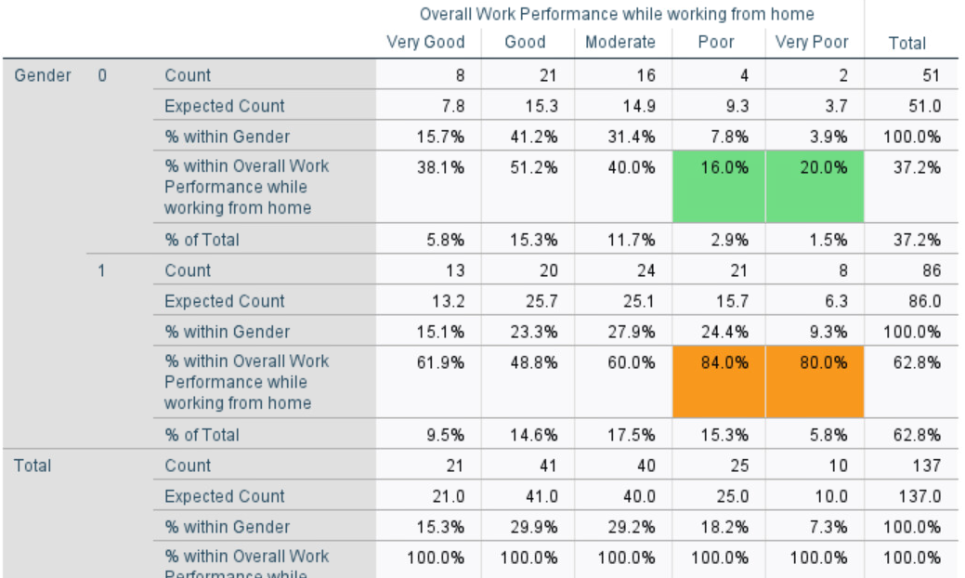

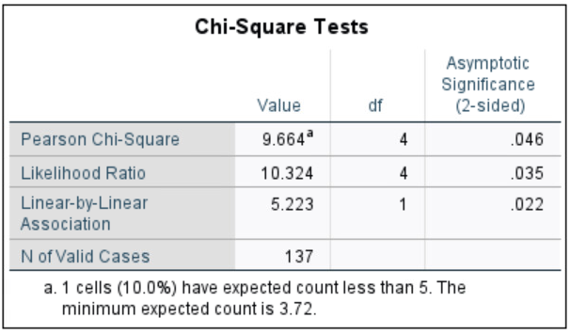

Fig 14: Chi-Square Test for Overall Work Performance while working from home (Gender)

***Gender vs On-site Performance***

In the crosstab of our output of Chi-square analysis, we can see out of 137, the total number of women are 51 (37.2%) and total number of men are 81 (62.8%) in our survey.While working On-Site, 29.4% of employees who reported Poor Performance and 33.3% of employees who reported Very Poor Performance were women. Whereas 70.6% and 66.7% of employees who reported poor and very poor performance respectively were men. Our chi square value is 1.653 with 4 as a freedom of degree and the p-value for this analysis is 0.799 which is more than 0.05. So, our observed results are not statistically significantly different from the expected value. Hence, we fail to reject the Null Hypothesis. (χ2 = 1.653, df = 4, p<0.799) 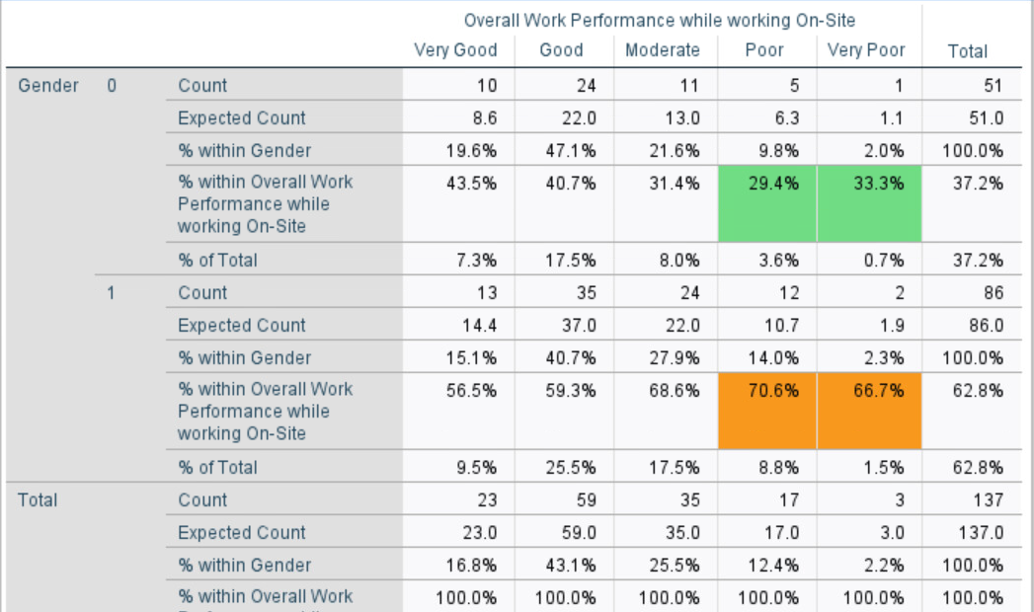

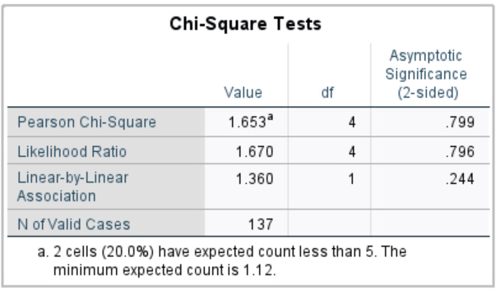

Fig 15: Chi-Square Test for Overall Work Performance while working on-site (Gender)

**Chi-Square Analysis on Experience vs. Performance**

***Experience vs Work from Home Performance***

8.3% and 33.3% of the employees with 1 year of experience reported very good and good performance while working from home . Whereas 25% and 50% employees with 4 years of experience reported very good and good performance while working from home. Our chi square value is 158.711 with 164 as a freedom of degree and the p-value for this analysis is 0.602 which is more than 0.05. So, our observed results are not statistically significantly different from the expected value. Hence, we fail to reject the Null Hypothesis. (χ2 = 158.711, df = 164, p<0.602)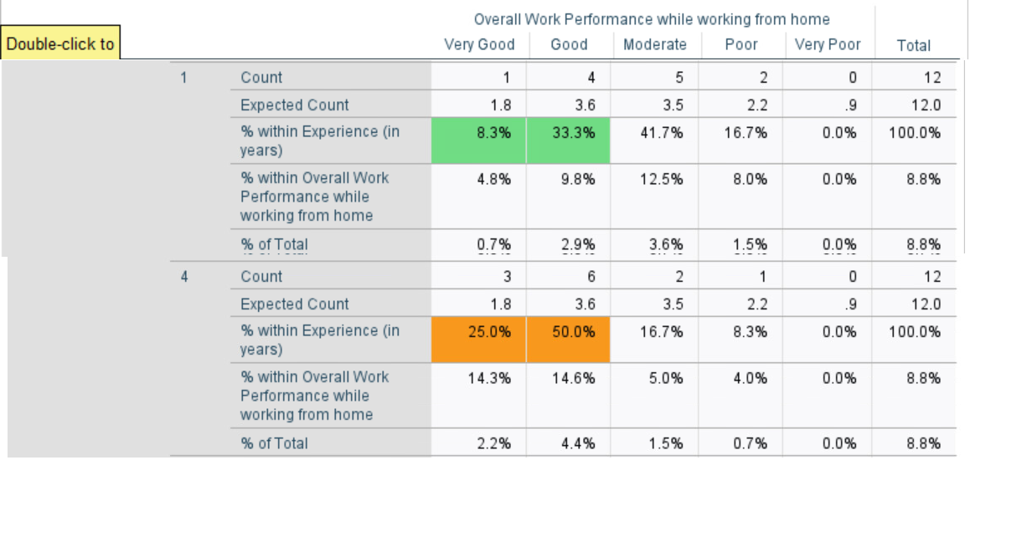

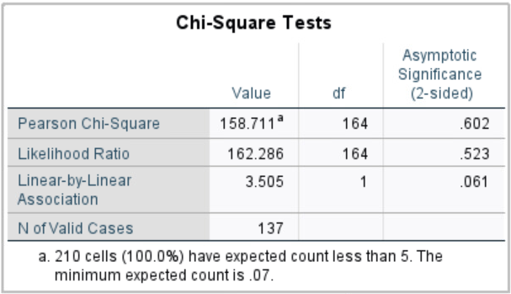

Fig 16: Chi-Square Test for Overall Work Performance while working from home (Experience)

***Experience vs On-site Performance***

While working On-Site, 8.3% and 50% of the employees with 1 year of experience reported very good and good performance. Whereas 16.7% and 50% employees with 4 years of experience reported very good and good performance while working from home. Our chi square value is 130.865 with 164 as a freedom of degree and the p-value for this analysis is 0.973 which is more than 0.05. So, our observed results are not statistically significantly different from the expected value. Hence, we fail to reject the Null Hypothesis. (χ2 = 130.865, df = 164 , p<0.973)

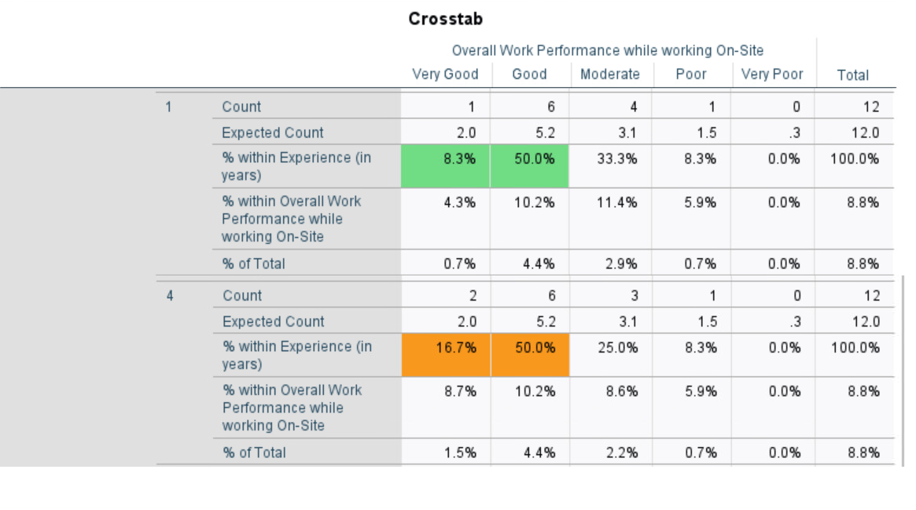

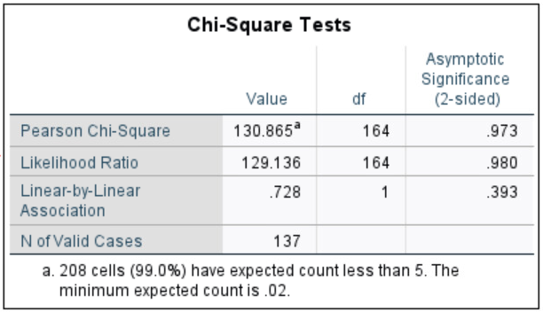

Fig 17: Chi-Square Test for Overall Work Performance while working on-site (Experience)

**Chi-Square Analysis on Experience vs. Performance**

Out of all the surveyed employees 40.9% were unwed and 59.1% were married.

***Marital Status vs Work from Home Performance***

In the crosstab of our output of Chi-square analysis, we can see out of 137, the total number of unmarried respondents are 56 (40.9%) and total number of married respondents are 81 (59.1%) in our survey.17.9% and 30.4% of the unwed employees reported very good performance and good performance respectively. Although quite close but 13.6% and 29.6% of the married employees reported very good performance and good performance respectively while working from home. Our chi square value is 1.180 with 4 as a freedom of degree and the p-value for this analysis is 0.881 which is less than 0.05. So, our observed results are statistically significantly different than expected value. Hence, we will reject our Null Hypothesis. (χ2 =1.18 , df=4 , p<0.881 )

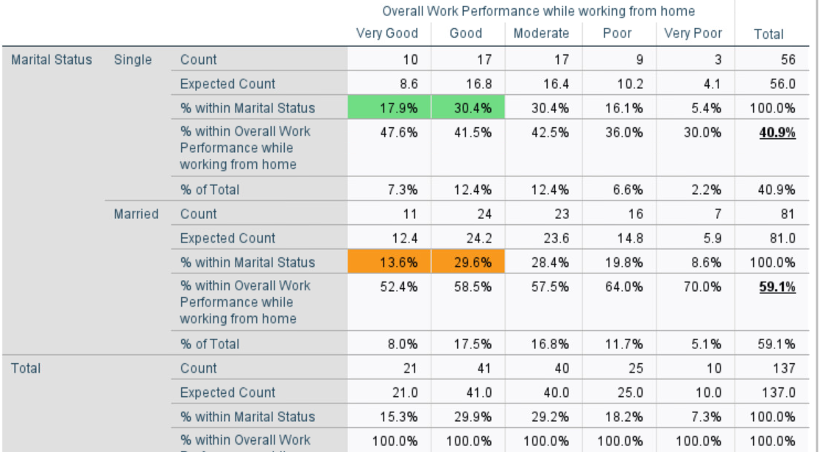

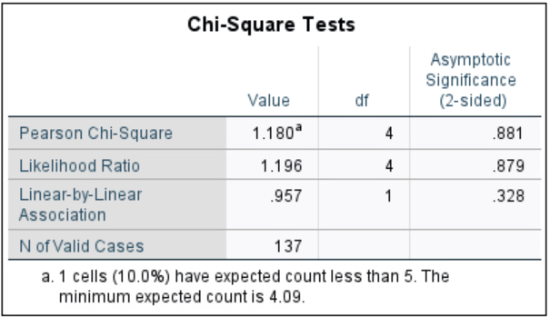

Fig 17: Chi-Square Test for Overall Work Performance while working from home (Marital Status)

**Marital Status vs On-site Performance**

In the crosstab of our output of Chi-square analysis, we can see out of 137, the total number of unmarried respondents are 56 (40.9%) and total number of married respondents are 81 (59.1%) in our survey.While working On-Site 14.3% and 50% of the Unmarried employees reported very good performance and good performance respectively. Whereas 18.5% and 38.4% of the married employees reported very good performance and good performance respectively. Our chi square value is 3.085 with 4 as a freedom of degree and the p-value for this analysis is 0.544 which is less than 0.05. So, our observed results are statistically significantly different than expected value. Hence, we will reject our Null Hypothesis. (χ2 =3.085 , df=4 , p<0.544 )

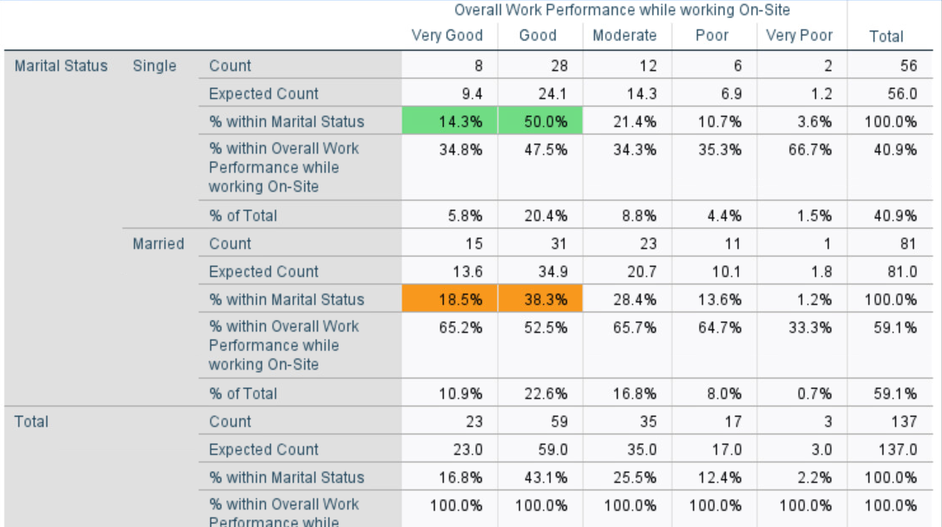

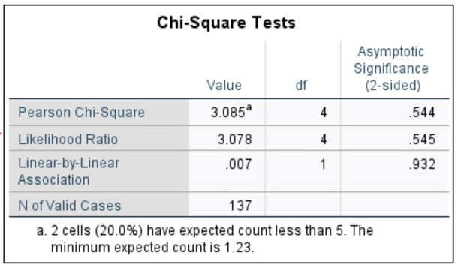

Fig 18: Chi-Square Test for Overall Work Performance while working on-site (Marital Status)

**C. Regression Analysis:**

Regression Analysis was performed to check if certain variables had any impact on the topic of interest.

The two important factors to consider in a Regression Analysis are below:

Dependent Variable: Main factor that you are trying to understand or predict

Independent Variable: Factors that we hypothesize have an impact on the dependent variable

Two regression analyses were performed. One on ‘Overall Work Performance while working from home’ and the other on ‘Overall Work Performance while working On-Site’

**Analysis for Overall Work Performance while working from home:**

Independent Variables: Age, Experience (in years)

Dependent Variable: Overall Work Performance while working from home

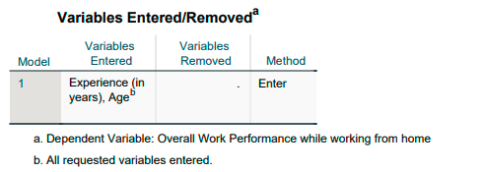

Fig 19: Variables Entered

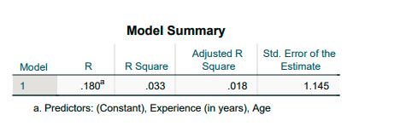

Fig 20: Model Summary

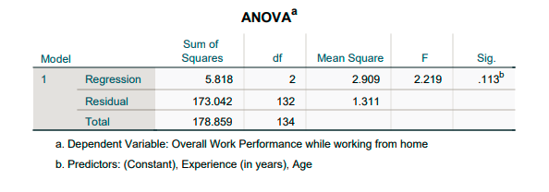

Fig 21: Analysis of Variance

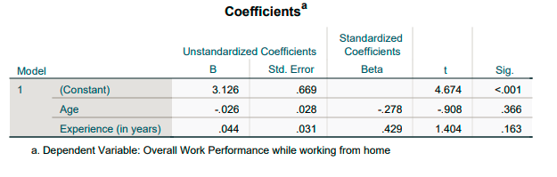

Fig 22: Coefficients Table

**Result of Analysis:** The hypothesis tests if employee performance doesn’t depend on an employee’s personal factors. The dependent variable ‘***Overall Work Performance while working from home***’ was regressed on predicting variables like Age and Experience (in years). The F-value is 2.219 and R-square value is 0.033 (3.3%) which indicates there is no significant relation between the Dependent and Independent variables. The p-value is 0.113 which is greater than 0.05, indicating this model cannot be used.

**Analysis Overall Work Performance while working On-Site:**

Independent Variables: Age, Experience (in years)

Dependent Variable: Overall Work Performance while working On-Site

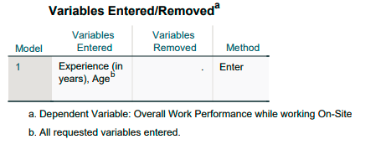

Fig 23: Variables Entered

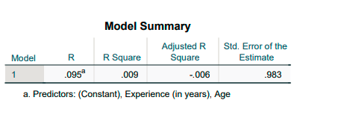

Fig 24: Models Summary

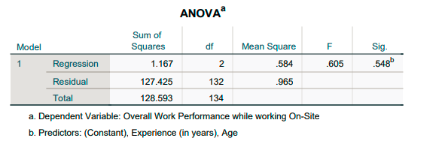

Fig 25: Analysis of Variance

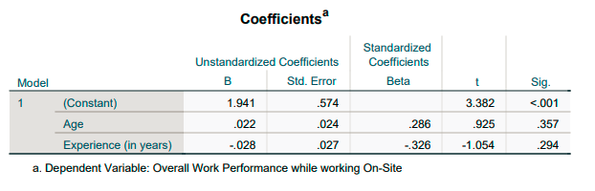

Fig 26: Coefficients Table

**Result of Analysis:** The hypothesis tests if employee performance doesn’t depend on an employee’s personal factors. The dependent variable ***‘Overall Work Performance while working On-Site’*** was regressed on predicting variables like Age and Experience (in years). The F-value is 1.035 and R-square value is 0.009 (0.9%) which indicates there is no significant relation between the Dependent and Independent variables. The p-value is 0.548 which is greater than 0.05, indicating this model cannot be used.

**D. One-way ANOVA**

We have performed one way ANOVA analysis on four combinations as listed below:

We tried ANOVA with whatever variable we used because 1 way ANOVA is used when we have one categorical independent variable having more than 3 categories, and one quantitative dependent variable.

The columns actual mode of working and preferred mode of working qualifies for the independent variable criteria and performance while work from home is continuous variable so we took it as the dependent variable in our one-way analysis.

In the first analysis, we established the null hypothesis that all the work modes have the same means and are statistically significant.

**Preferred mode of working VS Overall work performance increase while working from home**

The significance value is (F2, 134 = 27.254, p < .001) we reject the null hypothesis and conclude that the means are different and there is a statistically significant difference between our group means.

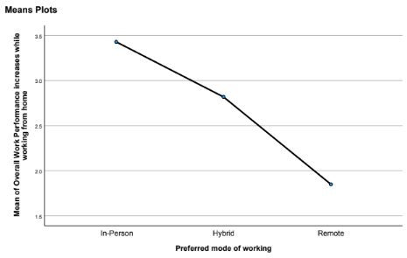

Fig 27: Mean of performance with Work from home vs Preferred mode of working

**Result of Analysis:**

The p-value of the one-way ANOVA analysis is less than 0.05 which suggests we can reject the null hypothesis and conclude that there is a statistically significant difference between work categories. We further performed the post doc analysis and found that the different group combinations are also statistically significant having p< 0.05.

Also, looking at the means plot of work performance vs preferred mode of working it is apparent that in-person employees saw the greatest increase in work performance while working from home.

**Actual Mode of Working vs Work Performance increase while working from home**

We reject the null hypothesis and conclude that there is a statistically significant difference in work categories. The post doc analysis suggests that the different group combinations are also statistically significant having p< 0.05.

The means plot suggests that remote employees feel the overall increase in work performance is not increased much while working from home. Opposite to which, the in-person employees feel that the performance is increased while working from home.

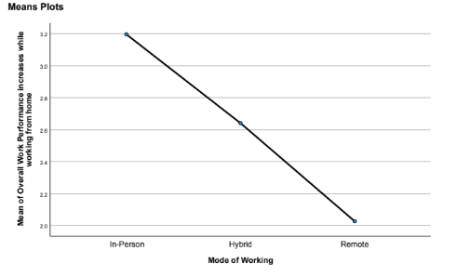

Fig 27: Mean of performance with Work from home vs Mode of working

**Explanation:** The p-value of this analysis was also less than 0.05 thus suggesting that there is a statistically significant difference in work categories.

The post doc analysis suggests that the different group combinations are also statistically significant having p< 0.05 for all combinations.

Now looking at the means plot, it suggests that employees who are already remote feel the overall increase in work performance is not increased much while working from home. Opposite to which, the in person employees feel that the performance is increased while working from home which gives us the idea that the companies should provide employees some flexibility to Work From Home as there is a performance increase.

**VIII. Discussion**

Based on the above analysis, we found that our Null hypothesis **Employee's personal factors do not affect employee's on-site performance and/or remote performance.**

The above analysis was done on a very limited dataset and most people from the tech industry. This study can be taken forward and analyzed based on segment or industry specific.

The results from our data suggest that human personal factors do not affect overall work performance. What then affects employee performance? We can speculate that a person's perception of work performance may play a role in data, which in turn may play a role in how they may actually perform at work.

For example, if one of our surveyed participants perceived that they performed ***well*** at work, and their mode of work was in-person, they were 28 years old, married, and had 5 years of work experience. Do their personal factors influence their work performance, or their perceptions of their factors affect their work performance? The only way to know for sure is to further question their history, and perhaps follow their work performance over a longer period and periodically survey them. In addition to following this participant, question a larger sample of similar participants with similar demographics, and background to understand if it is truly the factors that affect the work performance or the individual perceiving their factors affecting their work performance.

Studies that are based from self-reporting questionnaires often are subjective and offer insight into the persona of the subject and not of the factual information from an blind study that reports data from the manager's POV and personal data facts of the employee. In an article in SHRM titled, *Manager, Employee Perceptions of Performance Differ (2009, Hastings),*it states that employees tend to rate themselves higher than employers would rate them 50% of the time.

The article includes an excerpt from the author of, *Forced Ranking: Making Performance Management Work (Grote, HBSP, 2009)* which states that ..*“Research consistently demonstrates that individuals are notoriously inaccurate in assessing their own performance, and the poorer the performer, the higher (and more inaccurate) the self-assessment,” Grote says. “ ‘Know yourself’ may be good philosophical advice, but in assessing how good a job you’ve done, your boss knows better than you do.”* This suggests that employees rate themselves depending on how they perceive themselves and if this is the case, depending on how an individual sees themselves, will ultimately affect their perception of their work performance.

This also would suggest that if one's personal factors vary from age, marital status, mode of work, and/or years of experience, so may their perception be dependent or independent of these factors. Overall, our case study does prove that the personal factors that are represented in our study do not affect employee work performance.

**IX. Conclusion**

Based on the analysis done, only Gender seems to have a relationship with the Work Performance while working remotely. Other factors like Age, Experience and Marital Status do not seem to have any relationship with the Work performance. Another relationship that was found was with Mode of working and Preferred mode of working in correlation with Work performance while working remotely/on-site.

These results may conclude that personal factors do not necessarily affect the performance of either mode of work. This does preclude more future research in mode of work versus location of remote or in-person work among home locations worldwide.

**X. References**

Edwards, M. R., & Edwards, K. (2016). *Predictive HR Analytics*. Kogan Page Ltd.

Hastings, R. R. (2009). *Manager, Employee Perceptions of Performance Differ*. www.SHRM.org. https://www.shrm.org/resourcesandtools/hr-topics/employee-relations/pages/manageremployeeperceptions.aspx

# Robinson, B. (2022). *3 New Studies End Debate Over Effectiveness Of Hybrid And Remote Work, Bryan Robinson*. www.forbes.com. https://www.forbes.com/sites/bryanrobinson/2022/02/04/3-new-studies-end-debate-over-effectiveness-of-hybrid-and-remote-work/?sh=2a7a16fd59b2

# Glaeser, E., & Cutler, D. (2021). *You may get more work done at home. But you’d have better ideas at the office*. www.washingtonpost.com. https://www.washingtonpost.com/outlook/2021/09/24/working-home-productivity-pandemic-remote/